ABHINAV EDUCATION SOCIETY’S
ENGLISH MEDIUM SCHOOL & JR. COLLEGE
PRIMARY SECTION [CBSE]
II CBSE
ANNUAL EXAMINATION [2022-23]
Name : ____________________________________________________Roll no ____________
Subject : Environmental Studies Marks : 50 Date: _________________________
Examiner’s sign ______________________ Invigilator’s sign__________________________
______________________________________________________________________________
Q.1) | Fill in the blanks.[06]
1 | Polluted air can make us fall _______________
2 | Sun sets in a ________________ direction.
3 | India has the world's _________________ largest population.
4 | Moving air is known as __________________
5 | To find the direction to a place we need a _________________.
6 | The blue wheel in our national flag has __________ spokes.
Q.2) | Name the following.[04]
1 | Things that purify air __________________________________
2 | Capital of India________________________________________
3 | Fastest means of transport_______________________________
4 | The directions which magnetic compass show.
 | _____________________________________________________
Q.4) | Match the following.[04]
1 | Father of the nation a] East
2 | National sport b] Farmer
3 | Sun rise c] Mahatma Gandhi
4 | Tractor d] Hockey
Q.3) | Write True or False.[04]
1 | In deserts, people mostly travel by camels._________________
2 | The smoke released by vehicles does not causes air pollution.___
3 | There are four main directions.____________________
4 | Lotus is the national flower of India.__________________
Q.5) | Tick the correct option.[04]
1 | Always cross the road at the _____________
 | a) lion crossing
 | b) zebra crossing
 | c) tiger crossing
2 | When the wind blows with a high speed it is called _________
 | a) storm
 | b) a ball.
 | c) wind
3 | Our National Anthem is written by ______________
 | a) Bankimchandra Chatterjee
 | b) Mahatma Gandhiji
 | c) rabindranath tagore
4 | ________ is our national fruit.
 | a) Banana
 | b) Mango
 | c) Apple
Q.6) | Answer the following questions.[10]
1 | What do you mean by breeze?
Ans | ________________________________________________________________________
 | ________________________________________________________________________
2 | Write any two uses of air.
Ans | _______________________________________________________________________
 | _______________________________________________________________________
3 | Write the names of three means of transport.
Ans | _________________________________________________________________________
 | _________________________________________________________________________
4] | What is the use of magnetic compass?
Ans | _________________________________________________________________________
 | _________________________________________________________________________
5] | What does the saffron colour in our national flag teaches us ?
Ans | _________________________________________________________________________
Q.7 Write a short note on.[06]
1 | Water Transport
2 | _______________________________________________________________________  ________________________________________________________________________  _________________________________________________________________________  _________________________________________________________________________  National Animal : Tiger
3 | Air Pollution
Q.8 | Think and write the apropriate answer.[06]
1 | If the rising Sun is at the back of Richa, then which directions
 | will be at her back, right and left sides?
2 | Write any three ways by which we can keep air clean
Q.8 | Identify the pictures and write its name below.[03]
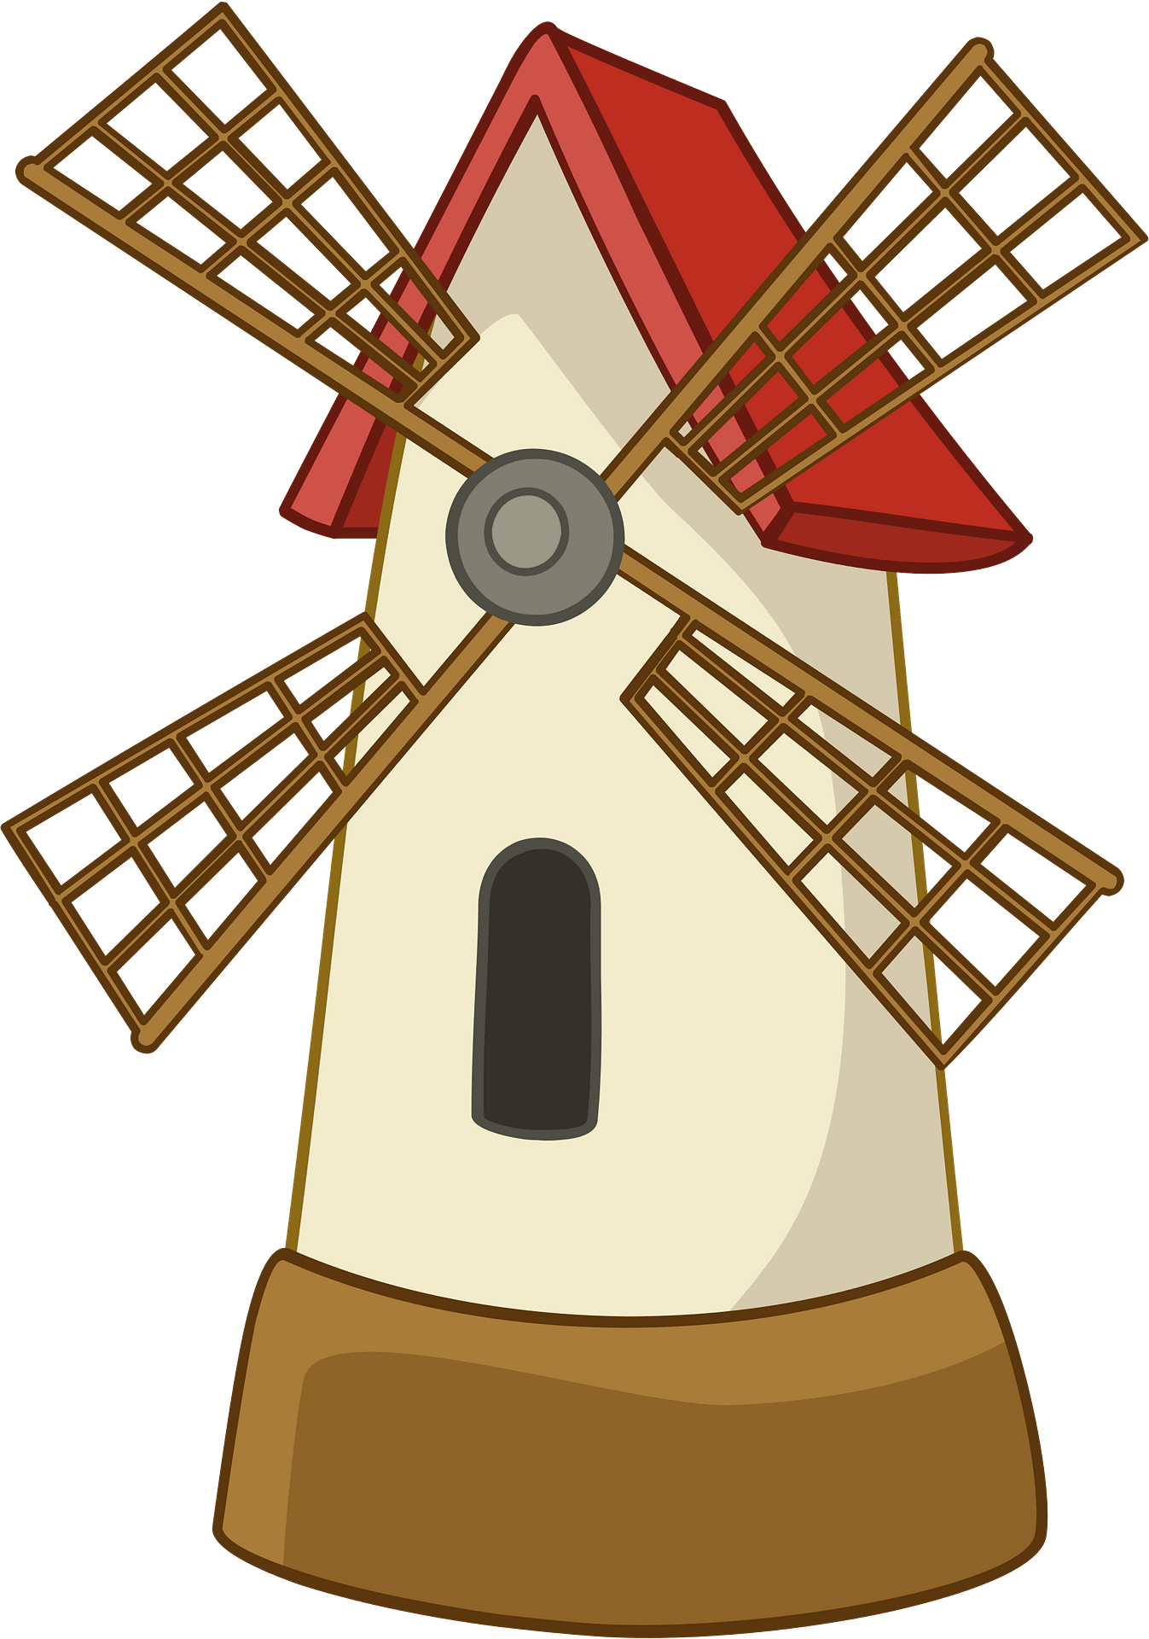 | 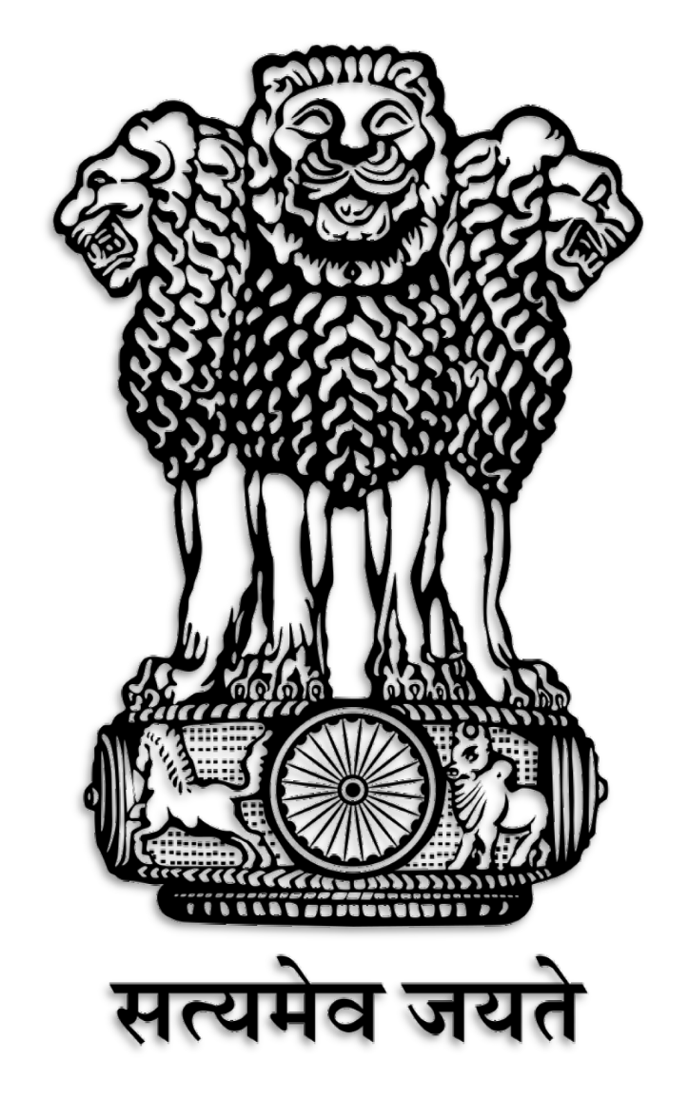  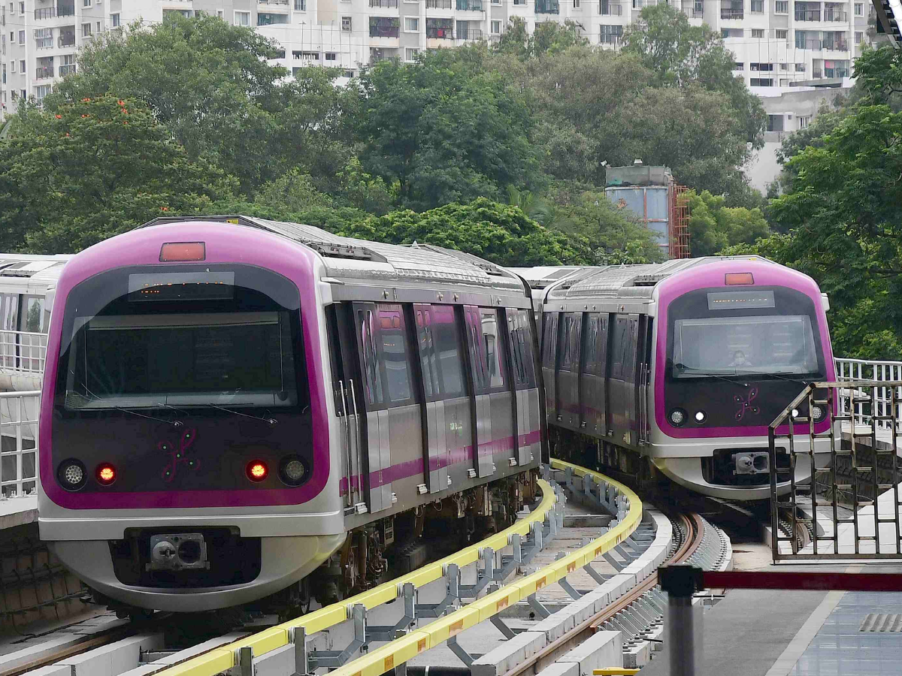
Q.9 | Draw the National flag of India and colour it. Also, tell the
 | importance of each colour and what they stand for in the
 | space provided below.[03]

